**Utilizing Air Quality Data to Influence Policy at the Creative Computing Institute (CCI)**

The Creative Computing Institute (CCI) has taken a commendable step towards improving environmental conditions by installing air quality sensors within its premises. This initiative aims to collect and analyse data to better understand indoor air quality, identify potential health risks, and implement policies that enhance the well-being of its community. This essay presents a comprehensive analysis of the data collected from these sensors, including visualizations, explanations of data presentation choices, and suggestions on how this data can be leveraged to influence policy at the CCI.

**Visualization of the Collected Data**

To effectively present the data, I will use several visualizations that highlight key aspects of air quality. The main parameters monitored by the sensors include carbon dioxide (CO2) levels, temperature, relative humidity, volatile organic compounds (VOCs), nitrogen oxides (NOx), and particulate matter (PM0.03, PM0.1, PM2.5 and PM10). These parameters are critical indicators of indoor air quality and have direct implications for health and comfort.

**Four key visualizations:**

1. CO2 Levels Over Time: A line graph displaying the fluctuations in CO2 levels over the observed period.

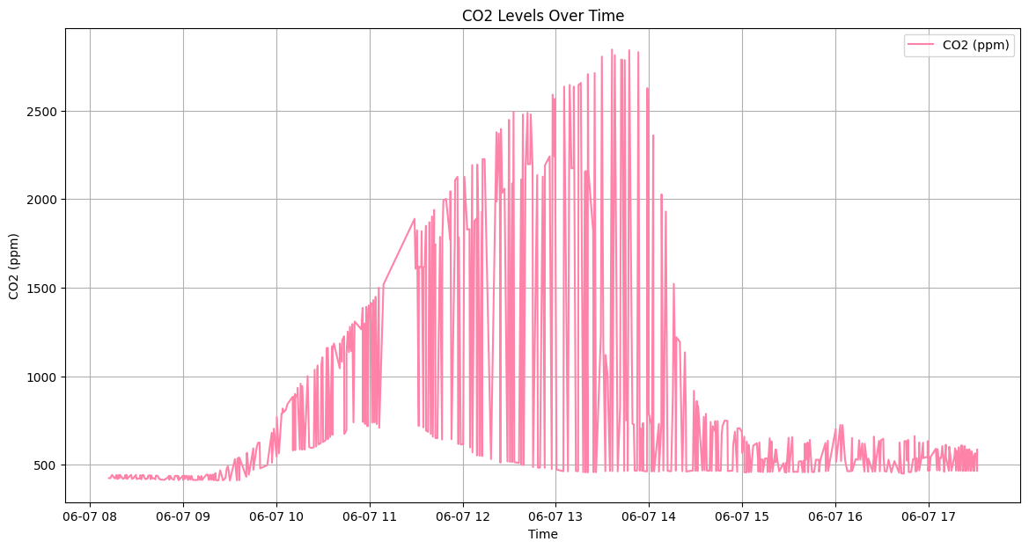

1. Temperature and Relative Humidity Over Time: A dual-axis line graph showing the variations in temperature and relative humidity simultaneously.

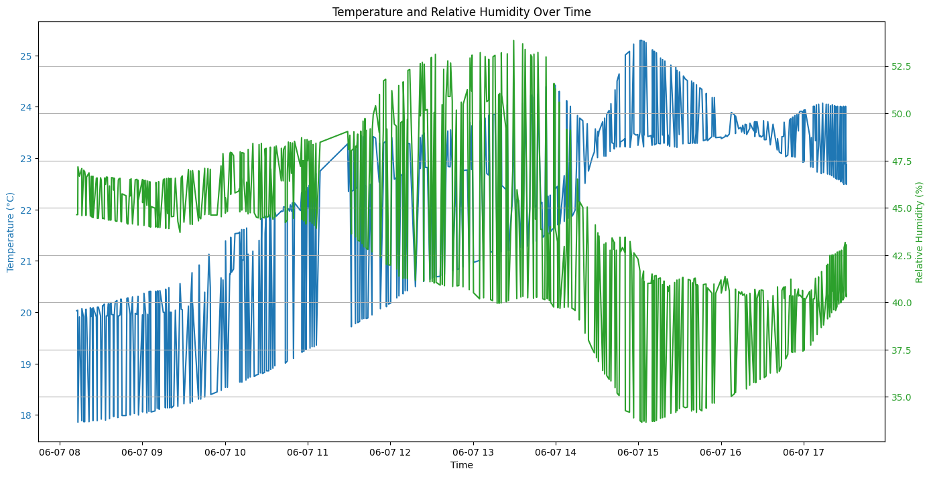

1. TVOC and NOx Index Over Time: A line graph illustrating the changes in TVOC and NOx index values.

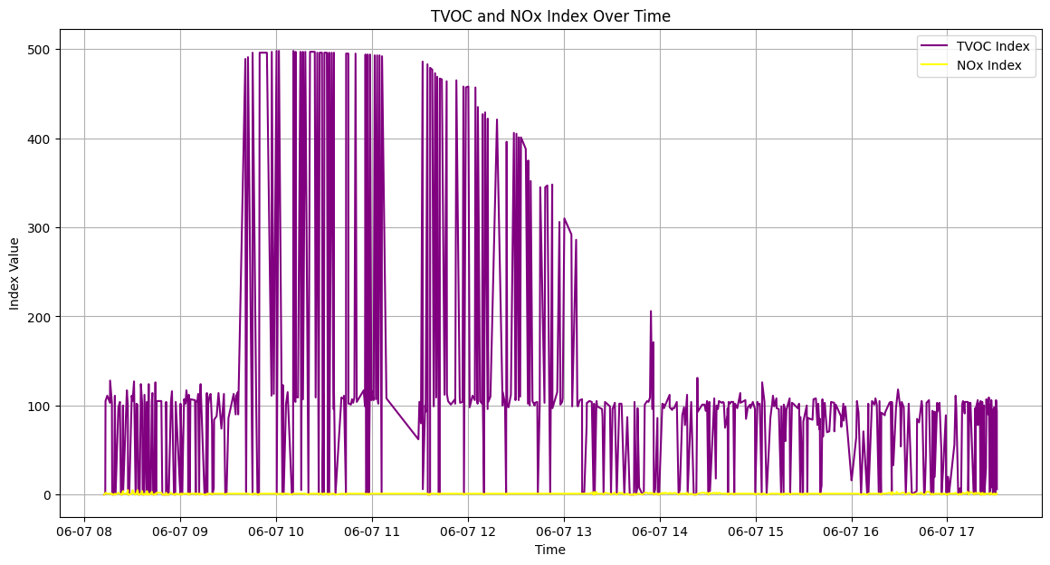

1. Particulate Matter (PM2 and PM10) Over Time: A line graph highlighting the levels of PM2.5 and PM10 over time.

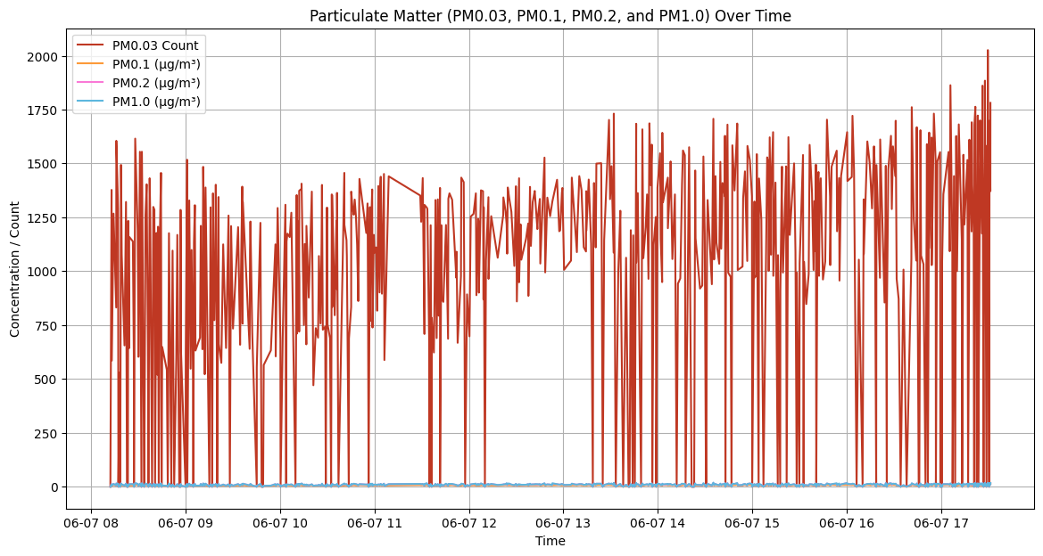

These visualizations will help in understanding the temporal patterns and potential sources of air quality issues within the CCI.

**Explanation of Data Display Choices**

Line graphs are chosen for their ability to clearly show trends and variations over time. They are particularly useful for continuous data, such as air quality measurements, where it is important to observe changes and identify patterns.

Dual-Axis Graph for Temperature and Humidity - The dual-axis graph effectively presents two related parameters that might influence each other. This format allows us to see correlations between temperature and humidity, which can have combined effects on air quality and comfort.

Index Values for TVOC and NOx - Displaying TVOC and NOx as index values provides a straightforward way to interpret complex chemical measurements, making it easier for non-experts to understand potential air quality issues.

Particulate Matter Concentrations – PM0.03, PM0.1, PM0.2, PM1.0 levels are critical for assessing air quality, especially concerning respiratory health. A line graph depicting these values helps in identifying spikes and trends that might correspond to specific events or activities within the CCI.

**Why is it Important to Maintain Indoor Air Quality on Human Health and Productivity**

Maintaining indoor air quality (IAQ) is crucial for safeguarding human health and productivity. The impact of IAQ on health and productivity is profound, as evidenced by a vast body of research. Poor IAQ can lead to a myriad of adverse health effects, ranging from respiratory issues to cognitive impairment, ultimately diminishing productivity and quality of life.

One of the primary concerns with poor IAQ is its contribution to respiratory problems. Indoor pollutants such as dust, mold, pet dander, and volatile organic compounds (VOCs) can exacerbate asthma, allergies, and other respiratory conditions. Fine particulate matter, commonly found in indoor environments, can penetrate deep into the lungs, triggering inflammation and respiratory distress. Prolonged exposure to these pollutants can worsen existing respiratory ailments and increase the risk of developing new ones. Furthermore, poor IAQ has been linked to cognitive impairment, affecting concentration, memory, and decision-making abilities. Indoor pollutants, including carbon dioxide (CO2) and volatile organic compounds (VOCs) emitted from building materials, furniture, and cleaning products, can impair cognitive function and mental clarity. Research indicates that high levels of CO2 can lead to drowsiness, headaches, and difficulty concentrating, all of which can hinder productivity and performance in educational and work settings.

The economic implications of poor IAQ are significant for organizations. Health-related absenteeism and decreased productivity due to poor IAQ can result in substantial financial losses. Employees working in environments with poor IAQ are more likely to take sick leave or experience reduced productivity due to health issues. Moreover, poor IAQ can contribute to higher healthcare costs for organizations, as employees seek medical treatment for respiratory ailments and other health problems associated with indoor air pollution. Investing in measures to improve IAQ can yield significant returns for organizations. Implementing proper ventilation systems, air filtration devices, and regular maintenance protocols can mitigate indoor air pollutants and create a healthier, more productive indoor environment. Studies have shown that improving IAQ can lead to lower absenteeism rates, higher productivity levels, and improved overall well-being among building occupants.

Maintaining good indoor air quality is essential for promoting human health and productivity. By addressing common indoor pollutants and implementing effective IAQ management strategies, organizations can create healthier and more conducive indoor environments, benefiting both employees and the bottom line. The initiative by the CCI underscores the importance of prioritizing IAQ and underscores its role in fostering a healthier and more productive society.

**Using Data to Affect Policy at the CCI**

The information collected from air quality sensors at the CCI is a valuable asset for creating a healthier and more sustainable environment. By analyzing this data, the CCI can make informed decisions about policies, infrastructure, and educational initiatives that directly impact the well-being of its occupants. The data collected from the air quality sensors can play a pivotal role in shaping environmental policies at the CCI. Here are several ways this data can be utilized:

1. Identifying Problem Areas:
   1. Continuous monitoring of air quality can pinpoint specific locations within the CCI where pollution levels are consistently high.
   2. This targeted approach allows for focused interventions, such as:
      1. Improving ventilation in specific rooms or areas.
      2. Adjusting HVAC (Heating, Ventilation, and Air Conditioning) settings for optimal air circulation and filtration.
      3. Identifying sources of pollution (e.g., high traffic areas, construction zones) and implementing solutions to mitigate their impact.
2. Setting Thresholds and Alerts:
   1. Establishing safe thresholds for various pollutants (e.g., CO2, PM2.5, VOCs) and setting up an alert system enables quick action when air quality deteriorates.
   2. This proactive approach can prevent prolonged exposure to harmful pollutants, protecting the health of occupants and reducing potential risks.
   3. Alerts can trigger automated responses, such as increasing ventilation rates or activating air purification systems.
3. Informing Maintenance Schedules:
   1. Data on particulate matter and VOCs can be utilized to optimize maintenance schedules for air filtration systems and other relevant infrastructure.
   2. By understanding the accumulation of pollutants, maintenance can be timed to ensure peak performance of air purification systems and a healthier environment.
   3. Regular maintenance can also extend the lifespan of equipment and reduce operational costs in the long run.
4. Educational Initiatives:
   1. Air quality data can be used to educate students, staff, and visitors about the importance of indoor air quality and its impact on health and productivity.
   2. Workshops and training sessions can raise awareness about individual behaviors that affect air quality and promote best practices for maintaining a healthy indoor environment.
   3. Empowering occupants with knowledge fosters a culture of responsibility and encourages participation in maintaining good air quality.
5. Policy Development:
   1. Analyzing long-term air quality trends can inform the development of comprehensive environmental policies for the CCI.
   2. This can include guidelines on:
      1. Building design and material selection to minimize the use of materials that release harmful pollutants.
      2. Occupancy management strategies to optimize ventilation and air circulation based on occupancy levels.
      3. Regular air quality monitoring and reporting to ensure ongoing compliance and continuous improvement.

By leveraging air quality data in these ways, the CCI can create a healthier, more comfortable, and more productive environment for all occupants while demonstrating its commitment to sustainability and environmental responsibility.

**Critical Analysis of the Data**

The data gleaned from air quality sensors at the CCI is a valuable resource for decision-making. However, to ensure that this data is reliable and useful, it's important to critically assess its limitations and potential areas for improvement. Let's delve deeper into each of the points raised:

1. Data Completeness and Accuracy:
   1. Calibration Frequency: Sensors should be calibrated according to manufacturer recommendations or industry best practices. This may involve using a known reference gas or particle concentration to adjust the sensor's readings. Regular calibration ensures that the sensor's output remains accurate over time.
   2. Identifying Data Gaps: Data gaps can occur due to sensor malfunction, power outages, or network connectivity issues. It's crucial to have mechanisms in place to detect these gaps promptly and, if possible, fill them using interpolation or other suitable methods.
   3. Outlier Detection and Removal: Outliers can skew the data analysis and lead to incorrect conclusions. Implement statistical methods or algorithms to identify and remove outliers while ensuring that valid data points are not discarded.
2. Temporal Resolution:
   1. Sampling Frequency: The appropriate sampling frequency depends on the specific pollutants being monitored and the desired level of detail. For rapidly changing pollutants like carbon dioxide, a higher sampling frequency (e.g., every minute) might be necessary. For pollutants with slower variations, a lower frequency (e.g., every hour) might suffice.
   2. Trend Analysis: Consider using statistical tools to analyze trends over time. This can help identify patterns that might not be apparent from individual data points. For example, you could use moving averages or other smoothing techniques to visualize long-term trends.
3. Sensor Placement:
   1. Spatial Distribution: Place sensors in various locations throughout the CCI, including areas with high occupancy, areas near potential pollution sources (e.g., printers, kitchens), and areas with different ventilation patterns. This ensures that the data represents the diversity of indoor environments within the CCI.
   2. Height Placement: Consider placing sensors at different heights to capture variations in pollutant concentrations at different levels. Some pollutants might settle near the floor, while others might accumulate near the ceiling.
4. External Factors:
   1. Weather Data Integration: Integrate outdoor weather data, such as temperature, humidity, and wind speed, with the indoor air quality data. This allows for a more comprehensive analysis of how outdoor conditions influence indoor air quality.
   2. Occupancy Tracking: Implement occupancy sensors or utilize existing building management systems to track occupancy levels. This information can be correlated with air quality data to understand the impact of occupancy on pollutant concentrations.
   3. Traffic and Pollution Monitoring: If the CCI is located in an area with significant outdoor pollution sources (e.g., nearby roads, industrial facilities), consider monitoring outdoor pollution levels and incorporating this data into the analysis.
5. Data Interpretation:
   1. Expert Collaboration: Collaborate with environmental scientists, industrial hygienists, or other experts with experience in air quality management. These experts can provide guidance on data interpretation, help identify potential health risks, and recommend appropriate mitigation strategies.
   2. Benchmarking: Compare the CCI's indoor air quality data with established standards and guidelines, such as those provided by the World Health Organization or local regulatory agencies. This helps assess the overall health and safety of the indoor environment.
6. Long-term Monitoring:
   1. Data Archiving: Implement a robust system for archiving and storing air quality data. This ensures that historical data is available for future analysis and comparison.
   2. Regular Review: Establish a schedule for regular review and analysis of the air quality data. This can be done monthly, quarterly, or annually, depending on the specific needs of the CCI.
   3. Adaptive Policies: Be prepared to adjust and adapt air quality policies based on the insights gained from long-term monitoring. As new information becomes available, policies may need to be updated to ensure continued improvement in indoor air quality.

By systematically addressing these limitations and implementing these comprehensive improvements, the CCI can unlock the full potential of its air quality data. The institute will be equipped with a robust and reliable system to monitor, analyse, and respond to air quality fluctuations, ultimately creating a healthier, more comfortable, and more productive environment for all occupants.

**Conclusion**

The utilization of air quality data at the Creative Computing Institute (CCI) marks a significant stride towards fostering a healthier and more sustainable indoor environment. By meticulously collecting, analysing, and interpreting data from strategically placed sensors, the CCI can gain invaluable insights into the factors influencing air quality within its premises. This data-driven approach empowers the institute to make informed decisions regarding ventilation, filtration, occupancy management, and educational initiatives, all aimed at mitigating potential health risks and optimizing occupant well-being.

The World Health Organization (WHO) underscores the critical link between indoor air quality and human health, stating that "indoor air pollution is estimated to cause approximately 3.2 million premature deaths worldwide each year" (WHO, 2022). By proactively addressing air quality concerns, the CCI not only aligns with global health recommendations but also sets a positive example for other institutions to follow.

Furthermore, the CCI's commitment to data transparency and education fosters a culture of environmental responsibility among its occupants. By sharing air quality data and educating the community about its implications, the institute empowers individuals to make informed choices about their behaviours and contribute to a healthier indoor environment.

In conclusion, the integration of air quality data into policy-making at the CCI is a testament to the institute's dedication to the well-being of its community and the environment. By harnessing the power of data, the CCI is poised to create a space where innovation and creativity thrive in an atmosphere of optimal health and sustainability.

------------------------------------

References:

* World Health Organization. (2022). *WHO guidelines for indoor air quality: household fuel combustion*. World Health Organization.
* WHO Global air quality guidelines, 22 Sept 2021, <https://www.who.int/publications/i/item/9789240034228>.
* Pétremand, R., Suárez, G., Besançon, S., Dil, J. H., & Canu, I. G. (2022). A Real-Time Comparison of Four Particulate Matter Size Fractions in the Personal Breathing Zone of Paris Subway Workers: A Six-Week Prospective Study. *Sustainability*, *14*(10). <https://doi.org/10.3390/su14105999>
* GOV.UK, Accredited official statistics, <https://www.gov.uk/government/statistics/air-quality-statistics/concentrations-of-particulate-matter-pm10-and-pm25>
* Queensland Government, Chart air quality data, <https://apps.des.qld.gov.au/air-quality/chart/?parameter=131&station=pcer&date=08%2F06%2F2024>